Packaging, labeling, and shipping cremated remains for your Pet’s Memorial Reef
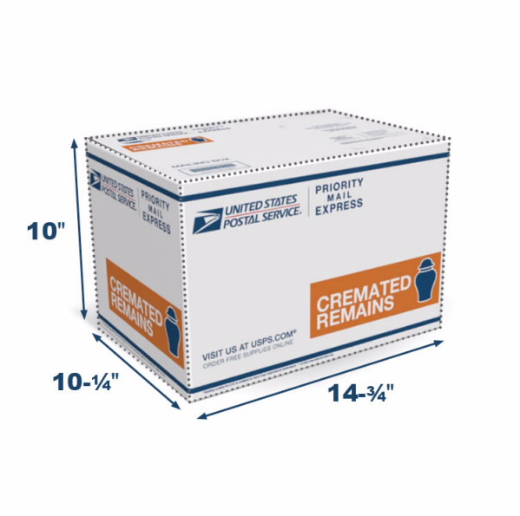
Ideally, cremated remains should be shipped to us via USPS Priority Express (UPS, Fed Ex, and DSL do not allow the shipment of cremated remains, nor will they deliver to our PO Box). Your cost of shipping depends on weight and distance – check with USPS for further cost information. This method provides peace of mind, as it includes tracking and is quick, usually arriving in 2 days. However, we will accept packages if they are mailed differently.

Order your free Cremated Remains shipping kit from the United States Postal Service (USPS) Online Store via this link. https://store.usps.com/store/product/shipping-supplies/cremated-remains-kit-2-P_BOX_CREKIT2
Kits are not available for pick-up at your local post office. Follow the instructions with the shipping kit to ensure safe delivery. For further information, the United States Postal Service shows the process in this video: https://www.youtube.com/watch?v=_a1sgiwhPdY

You may choose to send all or some of your pet’s cremated remains to be included in the Memorial Reef. Containers will not be returned, so please do not send cremated remains in an urn or container you wish to keep.

When preparing the shipping label, please email us your tracking number so that we can track your package from your location to ours. Please choose the address below that is closest to you.

Our Southeast Mailing address:
Pet Reefs by
Memorial Reefs International
P.O. Box 18172
Clearwater, FL 33762
Ph: 877-218-0747
Email: sales@petreefs.com

Our Northeast Mailing Address:
Pet Reefs by
Memorial Reefs International
458 Woodbine Ocean View Rd Ste B
Ocean View, NJ 08230
Ph: 877-218-0747
Email: sales@petreefs.com

If you have any questions, you may contact us at sales@petreefs.com or (877) 218-0747

Thank you for your order!

